SCHOOL of EDUCATION
LESSON PLAN TEMPLATE

Subject: Science Grade Level: 2nd
Date: March 27, 2013 Time Estimate: 30 min
Unit: Organisms and Environments TEKS: 112.113.9C
Topic: Land Habitats

Goal(s): TLW learn about various types of land habitats.

Objective(s): TLW identify pictures of land habitats.
TLW locate animals and characteristics of land habitats.
TLW demonstrate knowledge by

Materials/Resources/Technology Needs: powerpoint, computer, projector, paper, pencils, markers, discovery education video, document camera, stapler
________________________________________________________________________________

Instructional Procedures
Focusing Event: “Today we will continue to learn about habitats. We will be looking at two different land habitats which are the desert and forest.”

Teaching/ Learning Procedures:
Students will be asked to come to the floor with science journal
TTW play discovery education video while students watch
TLW analyze and compare picture of forest and desert habitats on powerpoint slides
TTW draw web on large piece of chart paper while students copy into science journal
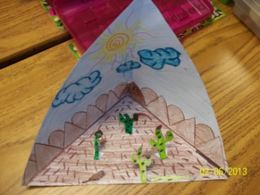
TTW dictate student suggestions for filling in web (should be animals, plants, temperature or anything else they see when thinking about each habitat
Once students are finished adding web to journal they will be asked to return to desk
Student will be given piece of white paper to start “pop-up habitat”
TTW model process of creating “pop-up habitat” using document camera

Formative Check (ongoing or specific): TTW check for comprehension throughout lesson by asking prompting questions, wait time, and having students add to discussion.

Re-teach (alternative used as needed): Pictures being displayed in powerpoint will be left up on smartboard so that students may use them as reference

Closure: “Who can tell me one thing they will remember from this activity?

Assessment/Summative Evaluation: TTW take science grade based on participation and finished “pop-up habitat”
________________________________________________________________________________
Modifications/Notes: Assign buddy to students who are struggling with concept.
Students can work in partners to check each other’s.

