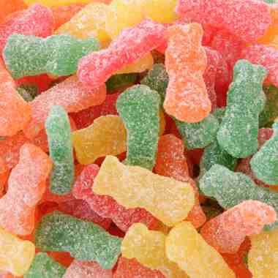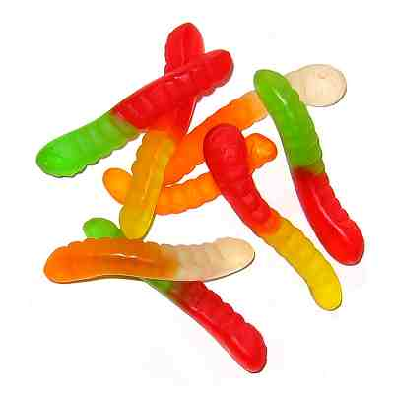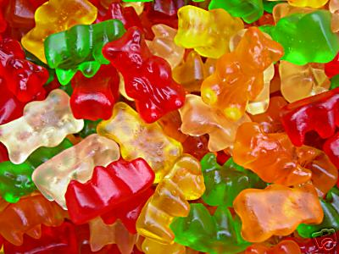**Materials List:**

Gummy worms, gummy bears, Sour Patch Kids, ruler, chair, desk, notebook, science book,

**Directions:** Ask yourself questions and answer them as you are completing the activities. Some example questions are:

**Observing:**

Use your senses to identify size, texture and color. What are some similarities between you and the bear? What are some words to describe the bear? Describe your thoughts in short sentences.

**Classifying:**

How can you organize the candies into different groups? What properties of the candies are different/similar among the candies?

**Measuring:**

Can you decide what will be an appropriate approximation? What device will be appropriate to use to measure the objects? Is a gummy worm suitable for measurement?

**Collecting and Organizing Data:**

How can you organize the data you are collecting? Why is this important? Place the gummy candy into groups. Put numbers in order to make it your data easy to read.

**Inferring:**

What can you tell after making your observations? What conclusions can you come to? What do your observations tell you?

**Predicting:**

What have you observed? What do you suspect will happen? Look at the size of each candy, and make a prediction.

**Controlling Variables:**

What stays the same in your experiment? What changes?

**Communicating:**

What will you say to be certain that others can understand your directions plainly? Describe the given object. Be sure to use pictures and labels.

**Process Integration:**

What were the different process skills you used in this activity?**OBSERVING**

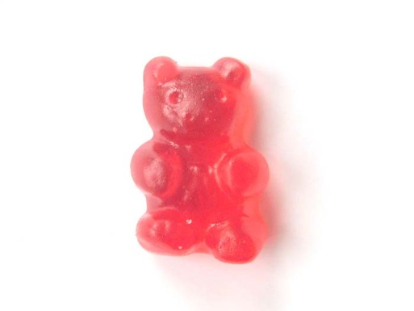Take one gummy bear. Describe the size, texture (what it feels like), and color of your bear. List 2 characteristics that you and the bear have in common.

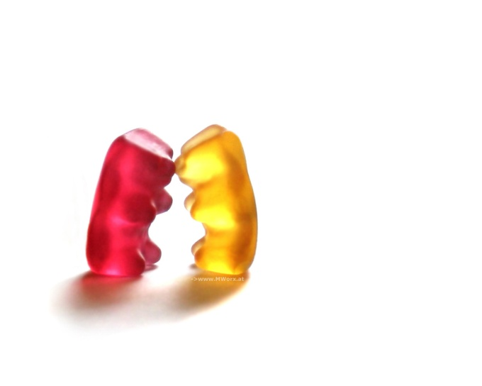

Write your description in sentences.

**CLASSIFYING**

Begin with 12 gummy candies (4 of each kind). Select one property and separate the candies into two groups (consider color, size, shape, and texture).

Think of another property and divide these two groups again. Sort the candies as many ways as possible. Write your properties above each block.

Use 15 gummy candies.

1. Place the candies in order from the smoothest in texture to the roughest. Write “GB” for gummy bear, “GW” for gummy worm, and “SPK for Sour Patch Kid under each type of candy.

**1 2 3 4 5**

**6 7 8 9 10**

**11 12 13 14 15**

1. Place the candies in order from the largest to the smallest. Use the same candy codes as in the previous activity to identify each type of candy.

**1 2 3 4 5**

**6 7 8 9 10**

**11 12 13 14 15**

1. Eat or taste one of each type of candy. Place the candies in order from sweetest to most sour. Use the same candy codes as in the previous activities to identify each type of candy.

**1 2 3 4 5**

**6 7 8 9 10**

**11 12 13 14 15**

**MEASURING**

1. Measure the length of a gummy worm.

The length is ________ in centimeters.

1. Line enough gummy worms to equal 1inch. How many gummy worms equal 1 inch?
2. Use your gummy worms as a unit of measurement. How many worms long or wide are the following objects?

|  |  |
| --- | --- |
| Object | Number of Gummy Worms |
| 1. Length of your pointer finger |  |
| 1. Width of your chair |  |
| 1. Length of your notebook |  |
| 1. Length of your Science book |  |
| 1. Length of your desk |  |

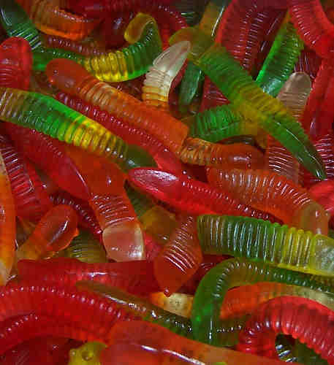

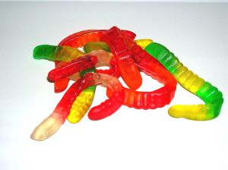**COLLECTING DATA**

1.Take all of the different gummy candy out of the bag and place them in the circle that is the same color as the candy. 2.Write the total amount of candies in the box under the circle. 3.Order the totals from least to greatest at the bottom of the page.

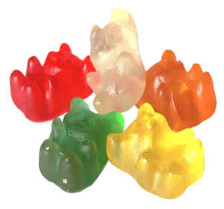

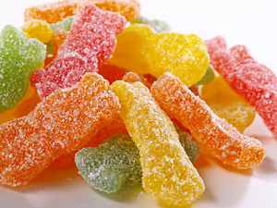

Least to Greatest…

**INFERRING**

Choose one of each type of gummy candy. Look at them very closely. Write down your observations. Make inferences about the gummy candies based on your observations. Think about the way(s) that the candies are targeted at children, how life-like the candies look, and the colors that are used in the gummy candies.

Write your observations.

____________________________________________________________________________________________________________________________________________________________________________________________________________________________________________________________________________________________________________________________________________________________________________________________________________________________________________________________________________________________________________________________________________________________________________________________________________________________________________________________________________________

Write your inferences.

____________________________________________________________________________________________________________________________________________________________________________________________________________________________________________________________________________________________________________________________________________________________________________________________________________________________________________________________________________________________________________________________________________________________________________________________________________________________________________________________________________________

**PREDICTING**

Answer the following questions by writing this line first, “I predict that…” State the candy that you think will be the longest based on your handling of the candies in earlier activities. Once you are finished answering all of the predictions, use your gummy worms, Sour Patch Kids or gummy bears to check your prediction.

1. If I lined two gummy worms together and five gummy bears together ___________________________________________________________
2. If I lined three Sour Patch Kids next to three gummy bears then ___________________________________________________________
3. If I lined one gummy worm with six Sour Patch Kids then ___________________________________________________________
4. If I lined three gummy worms up with ten Sour Patch Kids then ___________________________________________________________

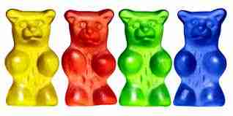

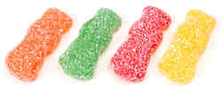

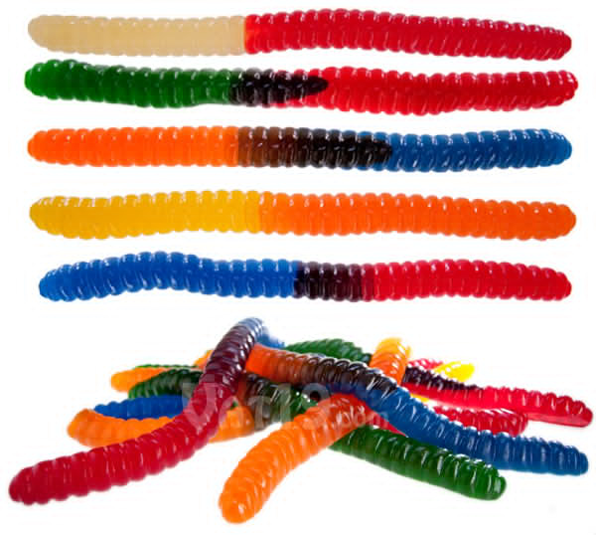

**CONTROLLING VARIABLES**

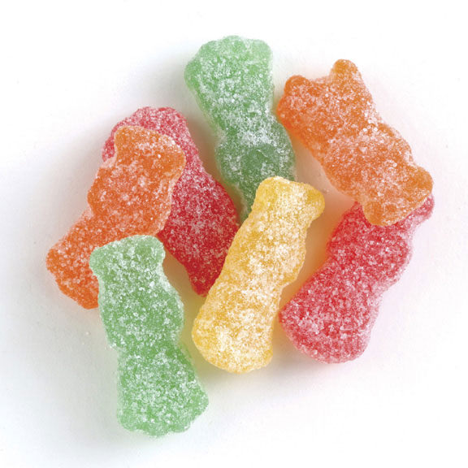Estimate how many gummy worms are equal to 1 foot/ 12 inches.

________________ **Estimated** Amount

Try it.

_________________ **Actual** Amount

**HYPOTHESIS**

Based on you understanding about the number of gummy worms there are in 1 foot. HYPOTHESIZE how many Sour Patch Kids it will equal to 6 inches.

Hypothesis:

Explain why you made this hypothesis:

C:\Users\Alyssa\AppData\Local\Microsoft\Windows\Temporary Internet Files\Content.IE5\HXY9TLXF\MC900383972[1].wmfTry it! Measure how many Sour Patch Kids really equal 6 inches.

**COMMUNICATING**

Have someone describe the details of a Sour Patch Kids candy. Try to draw the candy from their descriptions. When you are finished, observe your drawing and draw it correctly.

My drawing while I observed the Sour Patch Kid:

My drawing with oral directions:

**PROCESS INTEGRATION**

1. Predict which gummy candy will stretch the most before breaking.
2. Write your prediction: The ­­­­­­­­­­­­­_______________________________________ will stretch the farthest before breaking.
3. Measure and record the initial length of each gummy candy in the table below.
4. Using both hands, carefully stretch each gummy candy until the outer edges start to split.
5. With the help of a partner, hold the stretched candy next to a ruler to measure the stretched length.
6. Record the new length and find the difference between the first length measurement and the stretched length measurement.
7. Write which gummy candy stretched the farthest.

|  |  |  |  |
| --- | --- | --- | --- |
| **Type of Candy** | **Initial Measurement** | **Stretched Measurement** | **Length Difference** |
| Gummy Bears |  |  |  |
| Gummy Worms |  |  |  |
| Sour Patch Kids |  |  |  |

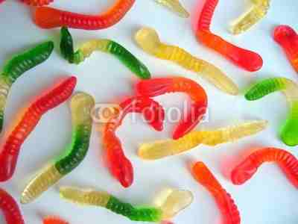The ­­­_____________________________ is the gummy candy that will stretch the most before breaking.

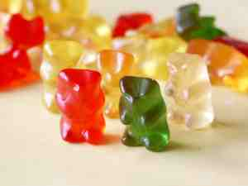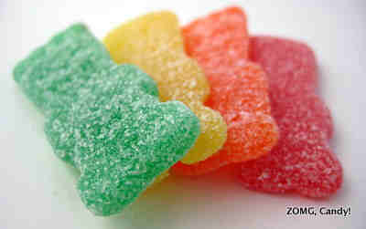

**EXTENDED ACTIVITIES**

Growth Spurt

Materials: gummy bears, gummy worms, Sour Patch Kids, three glasses of water, paper towels, a ruler

1. Write a prediction about what will happen when the gummy candies are placed in water overnight. Will they shrink, bloat, or stay the same?
2. Measure the length and width of each gummy candy and record in the table.
3. Put one gummy bear in one of the glasses with water, put one gummy worm in another of the glasses with water, and put one Sour Patch Kid in the last glass with water.
4. Place the glasses somewhere safe where they will not be disturbed.
5. Leave the gummy candies in the glasses of water for one full day.
6. The next day, take the gummy candies out and dry them on paper towels.
7. Measure the length and width of each gummy candy and record in the table.
8. Determine how much each gummy candy has or has not changed and if your prediction was correct or not.

Prediction:

______________________________________________________________________________________________________________________________________________________________________________________________________

|  |  |  |  |
| --- | --- | --- | --- |
| **Type of Candy** | **Initial Measurement**  **(length; width)** | **Measurement after Water**  **(length; width)** | **Difference**  **(length; width)** |
| Gummy Worm |  |  |  |
| Gummy Bear |  |  |  |
| Sour Patch Kid |  |  |  |

My prediction was correct/incorrect (circle one).